1. Project Overview

1.1 Project Title
Belt Joint Rupture and Conveyor Belt Damage Monitoring and Prediction in the Iron Ore Mining Industry
Team: TELENOVA
SIH Problem Statement: SIH26008

1.2 Executive Summary
Conveyor belts are critical to continuous material transportation in iron ore mining. Damage to the belt, particularly at splices/joints, can result in unplanned downtime, material spillage, equipment damage and significant maintenance costs.
TELENOVA proposes a joint-level intelligent condition-monitoring system that combines vibration, temperature, motor/load-related parameters and computer vision. Sensor signals are processed using DSP techniques and analysed using machine-learning models to identify abnormal behaviour, estimate joint health and predict potential failure.
The system maintains a digital health profile for individual belt joints, allowing the operator to observe degradation over time rather than relying only on a one-time fault alarm. A user-friendly dashboard provides belt-wide health visualization, joint-level status, alerts and maintenance recommendations.
The prototype is designed around low-cost edge processing, with computationally intensive analysis performed locally at an edge gateway rather than depending entirely on cloud connectivity.

1.3 Project Objectives
The project aims to:
- Detect conveyor-belt and joint abnormalities at an early stage.
- Identify individual belt joints and track their condition over repeated belt cycles.
- Combine multiple sensing modalities to improve diagnostic reliability.
- Apply DSP and ML to convert raw sensor signals into meaningful condition indicators.
- Develop a joint health score and degradation trend rather than relying only on binary fault detection.
- Estimate failure/rupture risk and maintenance priority.
- Provide operators with a simple visual dashboard instead of exposing them to complex sensor/DSP data.
- Demonstrate a pathway toward edge-based, scalable industrial deployment.

1.4 Core Concept
The central idea is:
Sense → Identify → Analyse → Predict → Act
Physical Conveyor
↓
Multiple Sensors
↓
Joint Identification
↓
DSP + Computer Vision
↓
Feature Extraction
↓
ML / Sensor Fusion
↓
Joint Health & Failure Risk
↓
Dashboard
↓
Maintenance / Control Recommendation
The project therefore moves beyond "Is the belt damaged?" toward:
"Which joint is degrading, how severe is the degradation, how is it changing, and when should maintenance be performed?"

1.5 Important Scope Clarification
For the prototype, TELENOVA is not claiming to replace established industrial NDT systems such as magnetic steel-cord inspection.
Magnetic inspection is already a mature technology. Research into magnetic conveyor-belt monitoring dates back to 1979, when CSIRO began developing a system for monitoring steel reinforcement in conveyor belts; commercial licensing followed that year.
Current commercial systems can already perform continuous steel-cord monitoring, splice analysis and rip detection. For example, Continental's systems use magnetic sensing for cord damage and splice monitoring, while its SpliceProtect system tracks splice elongation using magnetic markers embedded in the splice.
Therefore, TELENOVA's contribution is not "inventing belt monitoring."
The proposed contribution is the integration of low-cost multimodal sensing, joint-level identification, condition trending, predictive analytics and operator-oriented decision support, with particular consideration for retrofit deployment.
That distinction will be important when judges ask:
"What is actually new here?"

1.6 Expected Outcome
The final prototype should demonstrate that a conveyor monitoring system can transform raw sensor and visual data into:
Joint identification → condition assessment → health score → degradation trend → risk level → maintenance recommendation
rather than simply generating a fault alarm.

2. Problem Statement

2.1 Industry Background
Conveyor belt systems are a major part of bulk material handling in iron ore mining. They transport ore continuously between processes such as crushing, screening, stockpiling and processing.
Because conveyors often operate for long periods under high loads, failure of a belt or its splice can interrupt the entire material-handling chain.
The key challenge is therefore not simply detecting a failure after it occurs, but identifying degradation early enough to allow planned intervention.

2.2 Conveyor Belt System in Iron Ore Mining
A typical conveyor consists of:
- Belt — carries the ore.
- Head/drive pulley — provides the driving force.
- Tail pulley — redirects the belt at the return end.
- Idlers — support the loaded and return sections of the belt.
- Take-up system — maintains appropriate belt tension.
- Gearbox and motor — provide mechanical power.
- Scrapers/cleaners — remove material adhering to the belt.
- Splices/joints — connect belt sections into a continuous loop.
- Structural frame — supports the conveyor.
- Monitoring and protection systems — detect conditions such as belt slip, misalignment and belt damage.
For TELENOVA, the belt, splice, idler and drive system are particularly important because their operating condition produces measurable mechanical, thermal, acoustic and visual signatures.

2.3 Belt Joint / Splice Vulnerability
A conveyor belt is normally manufactured in sections and joined to form a continuous loop. The joining region is called a splice or joint.
The splice is a critical region because its mechanical behaviour differs from that of the continuous belt.
It can be affected by:
- repeated tensile loading
- cyclic bending around pulleys
- impact loading
- misalignment
- excessive tension
- temperature
- moisture and contamination
- improper installation
- wear and ageing
Progressive splice degradation can manifest as elongation, separation, cracking, delamination or structural weakening, eventually resulting in belt failure.
This makes the splice particularly suitable for condition-based monitoring, because changes in its behaviour may occur before complete rupture.

2.4 Types of Conveyor Belt Damage

A. Belt-body damage
- Longitudinal and transverse tears
- Surface cracks
- Cuts and punctures
- Edge damage
- Abrasion
- Delamination

B. Joint/splice damage
- Splice separation
- Splice elongation
- Cracking
- Delamination
- Localized structural weakening
- Complete splice rupture

C. Mechanical/system faults
- Idler bearing failure
- Pulley problems
- Belt misalignment
- Belt slip
- Abnormal tension
- Drive-system abnormalities

D. Operating/environmental abnormalities
- Overloading
- Excessive belt speed
- Material impact
- Temperature rise
- Dust/material accumulation
- Water/moisture exposure
For TELENOVA, splice degradation is the primary target; the other conditions are treated as contributing faults, confounding conditions or secondary monitoring targets.

2.5 Causes of Belt Damage
The major causes can be grouped as: Mechanical
Excessive tension, impact loading, misalignment, pulley/idler problems and repeated cyclic stress.
Operational: Overloading, excessive speed, improper loading and sudden changes in operating conditions.
Environmental: Temperature, moisture, dust, corrosive conditions and abrasive iron ore.
Material-related: Sharp ore, tramp material and oversized particles can cause cuts, punctures and impact damage.
Installation/maintenance: Poor splice preparation, incorrect tensioning, inadequate inspection or delayed maintenance.
A key point for the project is that damage rarely has a single measurable cause. This supports the use of multiple sensors rather than relying on one threshold.

2.6 Consequences of Belt Failure
A serious belt or splice failure can result in:
Operational impact
- Conveyor shutdown
- Production interruption
- Ore transportation delays
- Downstream process disruption
Safety impact
- Worker exposure during emergency inspection and repair
- Uncontrolled belt/material movement
- Increased risk during maintenance operations
Economic impact
- Emergency repair costs
- Replacement belt/splice costs
- Lost production
- Increased maintenance requirements
Environmental impact
- Ore spillage
- Material wastage
- Additional cleanup requirements
Therefore:
The cost of failure is significantly greater than the cost of detecting degradation early.
This is the fundamental justification for predictive maintenance.

2.7 Existing Maintenance Practices
The industry generally uses a combination of:

Preventive maintenance: Components are inspected or replaced according to:
- operating hours
- manufacturer recommendations
- maintenance schedules
- expected service life

Condition-based maintenance: Maintenance is triggered by measured conditions such as:
- vibration
- temperature
- belt tension
- belt alignment
- magnetic inspection results

Manual inspection: Personnel visually inspect:
- belt surfaces
- splices
- idlers
- pulleys
- structural components

Continuous protection: Dedicated systems can provide immediate responses to conditions such as:
- belt misalignment
- belt slip
- longitudinal belt rip
- emergency conditions
These approaches are important and TELENOVA is intended to complement rather than replace them.

2.8 Limitations of Existing Practices
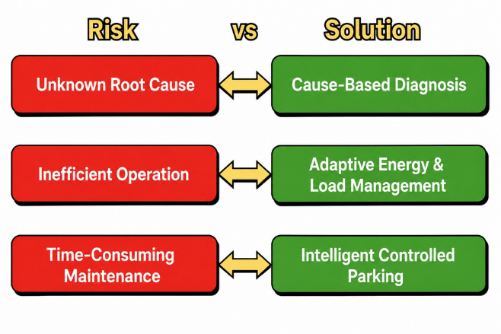
The central limitations relevant to your project are:

1. Periodic rather than continuous inspection
Manual inspection provides snapshots of belt condition rather than a continuous degradation history.

2. Detection is often modality-specific
A camera may detect visible damage while a vibration sensor detects mechanical abnormalities. One modality may not provide enough information to determine the actual failure mechanism.

3. Limited joint-level historical tracking
A joint may be identified as abnormal, but maintaining a longitudinal health trajectory for each individual joint is less common in low-cost monitoring systems.

4. Detection does not necessarily mean prediction
Many systems answer:
"Is there a fault?"
The more useful maintenance question is:
"Is this joint degrading, how quickly is it degrading, and when should it be inspected?"

5. High-end systems can be expensive
Advanced industrial NDT systems can require specialized sensors, installation and maintenance, making them less accessible for smaller operations or retrofit applications.

6. Harsh mining conditions
Dust, vibration, shock, temperature variation and variable belt loading make sensor reliability and model generalization challenging.

2.9 Problem Definition
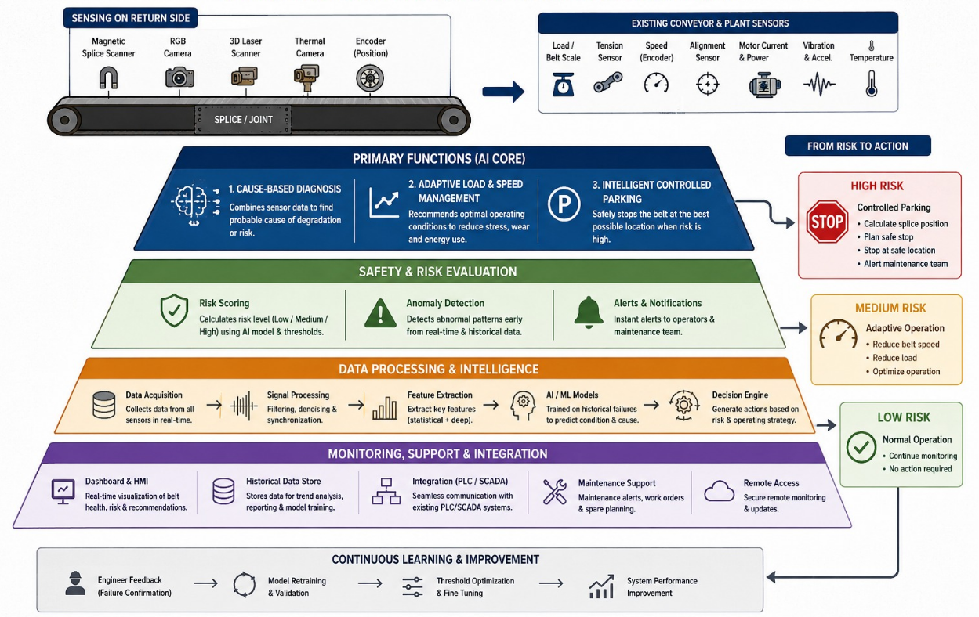
Therefore, the engineering problem addressed by TELENOVA is:
To develop a low-cost, retrofit-oriented monitoring system capable of identifying individual conveyor-belt joints, continuously assessing their condition using multiple sensing modalities, detecting abnormal degradation, and providing an interpretable prediction of failure risk and maintenance priority.

In short:
Current approach: Inspect → Detect fault → Repair

3. Existing Solutions & Research

3.1 History & Evolution of Conveyor Belt Damage Detection
Explain how the field progressed from manual inspection → mechanical protection → magnetic NDT → sensor monitoring → computer vision → AI/ML → multimodal predictive monitoring.

3.2 Conventional Monitoring Systems

Manual Visual Inspection
Operators periodically inspect:
- Belt surface
- Belt edges
- Splices/joints
- Idlers
- Pulleys
- Belt alignment
- Visible cracks, cuts and tears
Working:
Operator → Visual inspection → Identify defect → Record/Report → Maintenance

Advantages
- Very low equipment cost
- Can identify defects that automated systems may miss
- Requires little instrumentation

Limitations
- Periodic rather than continuous
- Human-dependent
- Difficult in dusty/low-visibility environments
- Small internal defects may remain undetected
- No continuous degradation history
- Cannot reliably predict when a joint will fail

3.3 Mechanical Protection Systems
These are already widely used as safety/protection systems, rather than predictive-maintenance systems.
Examples include:
- Belt misalignment switches
- Belt-slip detection
- Emergency-stop switches
- Belt-rip detection
- Speed monitoring
- Zero-speed switches

Working
Sensors monitor a predefined dangerous condition.
For example:
Belt deviates → Misalignment switch activates → Alarm/stop
or
Belt speed drops → Slip detected → Conveyor protection activated

Limitation
These systems generally answer:
"Has a dangerous condition occurred?"
rather than:
"Is this particular joint gradually degrading and likely to fail?"
This distinction is important for TELENOVA.

3.4 Magnetic Non-Destructive Testing
Magnetic inspection is one of the most established technologies for steel-cord conveyor belts.
The steel reinforcement inside the belt is magnetized. Damage to the steel cords changes the magnetic field, allowing the system to identify abnormalities.

Detectable conditions
- Broken steel cords
- Damaged cords
- Corrosion
- Missing cords
- Reduction in metallic cross-section
- Splice abnormalities

Basic principle
Magnet → Steel cord → Magnetic field → Sensor → Signal processing → Defect location
Historical research into magnetic conveyor-belt monitoring dates back to the late 1970s/early 1980s, and commercial systems subsequently developed around this principle.

Advantage
It can detect internal damage that cannot be seen from the belt surface.

Limitation
- Primarily applicable to steel-cord belts
- Specialized equipment is required
- Installation and calibration can be complex
- Higher cost than basic vibration/temperature sensing

Importance to TELENOVA
This technology establishes an important boundary:
TELENOVA should not claim that internal steel-cord damage has never been detected before.
Instead, TELENOVA can investigate whether lower-cost multimodal sensing and analytics can complement established NDT technologies.

3.5 Vibration-Based Monitoring
Accelerometers are mounted on suitable conveyor structures/components to measure mechanical vibration.

Detects
- Idler bearing faults
- Pulley abnormalities
- Mechanical imbalance
- Misalignment
- Structural looseness
- Abnormal mechanical loading

Working
Accelerometer → Raw vibration → Filtering → Feature extraction → ML/anomaly detection
Typical features:
- RMS
- Peak
- Variance
- Kurtosis
- Crest factor
- Frequency-domain peaks

Limitation
Vibration does not directly "see" a belt crack or splice separation.
Instead, the fault must produce a measurable mechanical signature.
Therefore:
Vibration is a strong supporting diagnostic modality, but not a complete belt-damage solution.

3.6 Acoustic Monitoring
Acoustic monitoring uses microphones to capture sound produced by conveyor components.
Different mechanical conditions can alter the acoustic signature.
For example:
Healthy idler → normal acoustic pattern
Damaged bearing → abnormal acoustic pattern
Machine-learning-based acoustic fault detection has already been demonstrated in conveyor-idler research using MFCC features and Gradient Boosted Decision Trees.

Working
Microphone → Noise reduction → Feature extraction → ML → Fault classification

Advantages
- Non-contact
- Relatively inexpensive
- Can operate continuously
- Useful for rotating mechanical components

Limitations
Mining environments produce significant:
- Ore impact noise
- Motor noise
- Gearbox noise
- Structural vibration
- Wind/dust-related noise
Therefore, acoustic monitoring benefits significantly from DSP and sensor fusion.

3.7 Vision-Based Inspection
Machine vision directly observes the belt surface.

Detectable defects
- Cracks
- Cuts
- Tears
- Edge damage
- Surface abrasion
- Splice abnormalities
- Belt misalignment
- Foreign objects

Working
Camera → Image acquisition → Preprocessing → Detection model → Defect classification → Location
Traditional approaches use:
- Thresholding
- Edge detection
- Segmentation
- Morphological operations
Modern systems increasingly use:
- CNNs
- YOLO
- EfficientNet
- Other deep-learning detectors
Recent literature shows that computer vision for conveyor monitoring has evolved considerably toward deep-learning-based detection.

Advantages
- Direct visual evidence
- Can locate the defect
- Non-contact
- Suitable for surface damage

Limitations
- Dust
- Lighting variations
- Motion blur
- Camera vibration
- Material covering the belt
- Cannot directly inspect internal steel cords

3.8 Thermal Monitoring
Thermal monitoring identifies abnormal temperature patterns.

Possible targets
- Idler/bearing overheating
- Motor overheating
- Pulley friction
- Belt slip
- Abnormal friction
- Localized heating

Working
IR sensor/thermal camera → Temperature measurement → Threshold/trend analysis → Alarm
Thermal cameras can additionally provide a spatial temperature map.

Limitation
Temperature abnormalities indicate that something is wrong, but temperature alone may not determine exactly what the fault is.
Therefore it is particularly useful as a supporting sensor.

3.9 AI/ML-Based Conveyor Monitoring
AI/ML is increasingly being placed above sensor and vision systems.
Instead of relying only on fixed thresholds:
Temperature > X → Alarm
ML can learn patterns associated with different operating conditions.

Typical models
Classical ML
- Random Forest
- XGBoost
- SVM
- Isolation Forest
Deep Learning
- 1D CNN
- Autoencoders
- LSTM/temporal models
- CNN/YOLO for images

Example
Sensor data:
Vibration ↑ + Temperature ↑ + Current ↑
AI can learn that the combined pattern may represent a particular abnormal condition.

Major limitation
AI performance depends heavily on:
- Dataset size
- Fault diversity
- Correct labelling
- Operating-condition variation
- Sensor quality
- Proper train/test separation
Therefore, "using AI" by itself is not an innovation.

3.10 IoT-Based Conveyor Monitoring
IoT connects distributed sensors to a central monitoring platform.

Typical architecture
Sensors → Edge device → Gateway → Database → Dashboard
It allows:
- Remote monitoring
- Continuous data collection
- Historical analysis
- Multiple conveyor monitoring
- Alerts
- Maintenance records
IoT therefore provides the connectivity and data infrastructure required for predictive maintenance.

3.11 Existing Industrial Systems
This section should go much deeper, because these systems are your real industrial benchmarks.

A. Continental Conveyor Monitoring
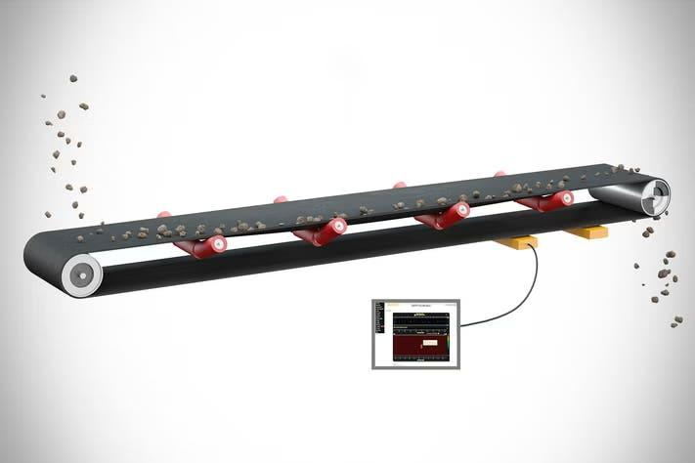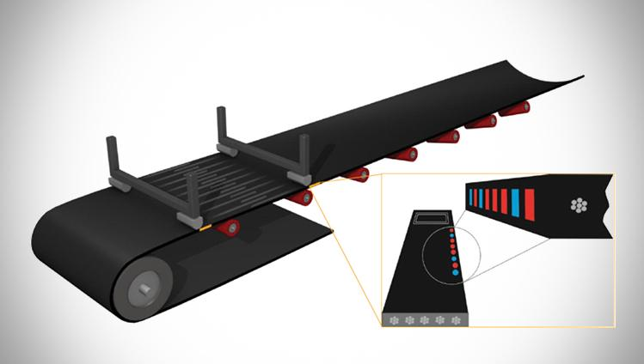

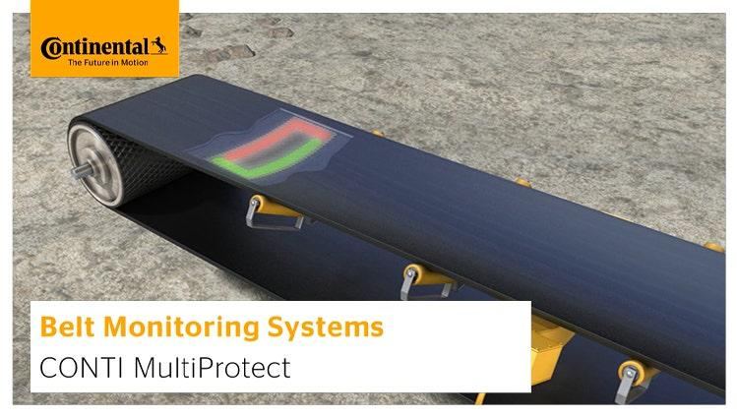
4
Continental has developed a portfolio of monitoring systems specifically for conveyor belts.

CONTI SpliceProtect
CONTI SpliceProtect is designed to monitor steel-cord belt splices.
Magnetic markers are incorporated into the splice. The monitoring system tracks the marker arrangement and measures changes in splice elongation.
It can therefore identify abnormal changes in the splice before a critical condition is reached.
The system can monitor multiple splices and can communicate monitoring information to the conveyor control system.

What it demonstrates
Joint-specific monitoring is already commercially possible.
This is extremely important for TELENOVA.

CONTI CordProtect
CONTI CordProtect uses magnetic sensing to continuously monitor the condition of steel cords inside the belt.
It can:
- Detect cord damage
- Determine the approximate location of damage
- Assess damage magnitude
- Track damage development
- Monitor splice signatures
Therefore, it goes beyond simple "belt damaged/not damaged" detection.
It creates information about where the damage is and how it changes over time.

CONTI MultiProtect
MultiProtect combines several protection/monitoring functions.
Its capabilities include monitoring related to:
- Longitudinal belt rip
- Steel-cord condition
- Splice condition
This demonstrates an important industry trend:
Combining multiple protection functions into one monitoring architecture.

B. Fenner Dunlop Eagle Eye
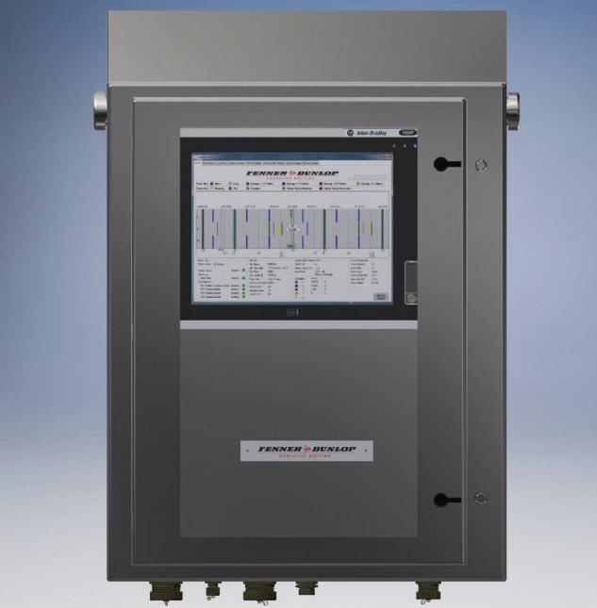

Fenner Dunlop's Eagle Eye is another industrial example of continuous conveyor-belt condition monitoring.
The system is designed for continuous steel-cord belt monitoring and provides information related to:
- Steel-cord condition
- Splice condition
- Belt rip
- Historical belt condition
A major feature is integration with conveyor control and maintenance information.

Significance
This demonstrates that industry is already moving toward:
Detection → Historical data → Maintenance planning
rather than simply triggering an emergency alarm.

3.12 Almex BeltGard
Almex BeltGard uses Magnetic Flux Leakage (MFL) principles for non-destructive inspection of steel-cable conveyor belts.
It can identify conditions such as:
- Cable damage
- Cable corrosion
- Splice deterioration
- Splice layout
- Location of defects
The system uses magnets, a sensor head and signal-processing electronics to inspect the belt.

Significance
Again, this establishes that internal belt-condition monitoring is an established industrial capability.

3.13 Research-Based Multimodal Systems
Research has also moved beyond individual sensors.
For example, studies have investigated:

Audio + Vision
A conveyor longitudinal-tear detection approach combined CCD imaging with microphone-array information.
The concept is:
Visual evidence + acoustic evidence → combined decision
This is relevant to TELENOVA because it demonstrates that sensor fusion is technically meaningful rather than simply an architectural idea.

Sensor Network + Digital Twin
Research has also demonstrated sensor networks for monitoring conveyor health through digital-twin approaches.
The concept is:
Physical conveyor → sensors → digital representation → condition monitoring
This represents the direction toward larger industrial predictive-maintenance platforms.

4. Proposed TELENOVA Solution

4.1 Solution Overview
TELENOVA proposes a multimodal, joint-level conveyor belt health-monitoring and predictive-maintenance system for iron-ore mining conveyors.The system combines multiple sensing and analysis techniques rather than depending on a single sensor.

Core pipeline
Conveyor Belt → Sensors + Camera → Edge Processing → DSP → Feature Extraction → AI/ML → Sensor Fusion → Joint Health Assessment → Dashboard → Maintenance Recommendation
The objective is to continuously determine:
- Which belt joint is being monitored
- What is its current condition
- Whether abnormal behaviour is occurring
- How severe the abnormality is
- Whether the condition is degrading
- Which joint requires attention first

4.2 Key Objectives
TELENOVA is designed around six primary objectives:

1. Continuous monitoring
Collect condition data continuously instead of depending only on periodic manual inspection.

2. Joint-level identification
Associate measurements with a specific belt joint/splice, rather than reporting only that "the conveyor has a fault."

3. Multimodal detection
Combine information from:
- Vibration
- Acoustic signals
- Temperature
- Motor current/load
- Belt speed
- Camera
This allows different physical symptoms of degradation to be analysed together.

4. Early anomaly detection
Identify abnormal behaviour before it develops into a major failure.

5. Predictive maintenance
Track the condition of a joint over time and generate:
- Health score
- Risk level
- Degradation trend
- Maintenance priority

6. Operator-friendly monitoring
Present complex DSP and ML results through a simple dashboard instead of requiring the operator to interpret raw signals.

4.3 Core Concept
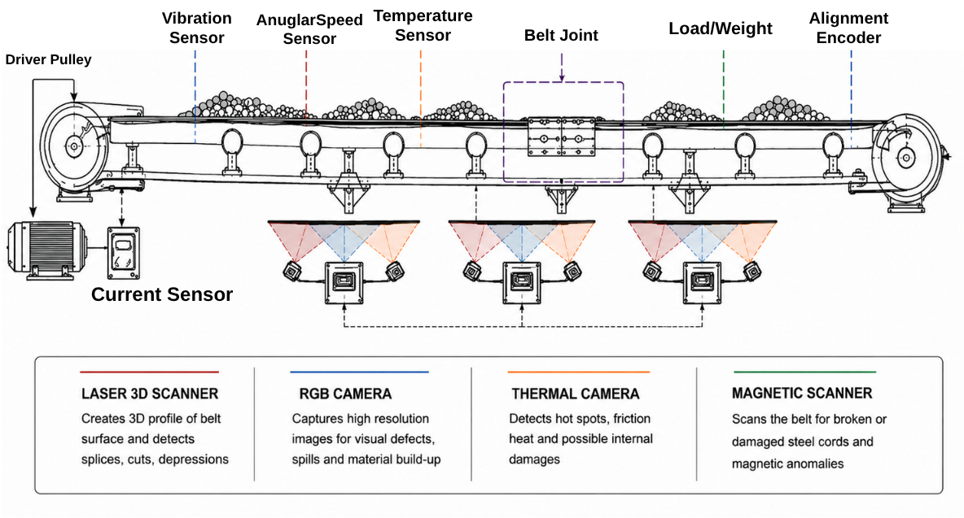
TELENOVA follows:

SENSE → IDENTIFY → ANALYSE → ASSESS → PREDICT → ACT

SENSE
Acquire data from multiple sensors.

IDENTIFY
Determine which belt section/joint is currently being observed.

ANALYSE
Process sensor signals using DSP and computer vision.

ASSESS
Use ML and sensor fusion to determine the condition.

PREDICT
Track degradation and estimate failure risk/maintenance priority.

ACT
Provide an actionable recommendation to the operator.

4.4 Key Features

A. Joint-Level Health Mapping
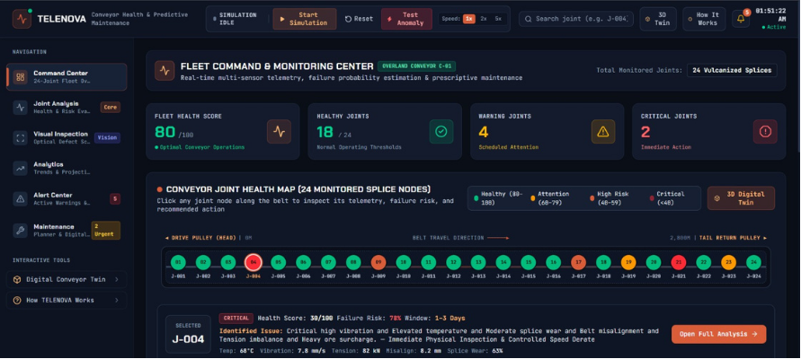
The dashboard represents the conveyor as a sequence of joints:
J1 → J2 → J3 → J4 → J5 → ... → Jn
Each joint receives a health state.
For example:
🟢 Healthy
🟡 Monitor
🟠 Inspection Required
🔴 Critical
This creates a digital health map of the conveyor.

B. Multisensor Condition Monitoring
Instead of relying on one measurement:
Vibration alone → Fault
TELENOVA combines multiple signals:
Vibration + Acoustic + Temperature + Current + Speed + Vision
This provides contextual information.
For example:
High vibration + normal temperature + normal current
may indicate a different condition from:
High vibration + increasing temperature + increased motor current.

4.5 Signal Processing Layer
DSP is used as a backend processing layer.
The operator does not need to understand:
- FFT
- Spectral density
- Filtering
- Wavelets
- MFCC
- Statistical signal features
The system converts these into meaningful outputs such as:
Joint J17: Increasing vibration anomaly
or
Joint J17: Abnormal acoustic signature detected
This keeps the system technically sophisticated while remaining usable in an industrial environment.

4.6 AI/ML Layer
Machine learning analyses the processed information.
A possible architecture is:

Edge anomaly detection
A lightweight model identifies abnormal behaviour close to the sensors.

Gateway-level analysis
A more capable model analyses combined features and determines:
- Fault probability
- Fault category
- Severity
- Joint health
Possible models include:
- Isolation Forest
- Random Forest
- XGBoost
- 1D CNN
The final model should be selected experimentally rather than assuming that a more complex model is automatically better.

4.7 Computer Vision Layer
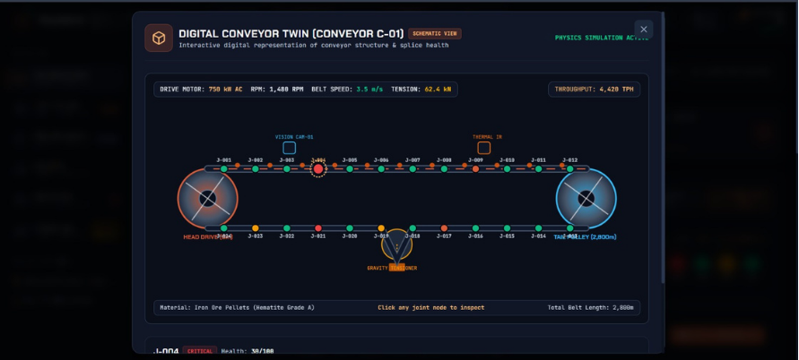
A camera continuously or periodically observes the belt.
The vision system can identify:
- Surface cracks
- Cuts
- Tears
- Edge damage
- Visible splice abnormalities
- Misalignment
- Foreign material
Vision provides direct visual evidence, while sensors provide information about mechanical and operational behaviour.
This makes them complementary.

4.8 Multimodal Sensor Fusion
This is one of the central parts of TELENOVA.
Instead of making independent decisions:
Vibration → Fault
Camera → Fault
Temperature → Fault
the system combines their evidence.

Example
Suppose Joint J12 shows:
- Vibration anomaly: 0.72
- Acoustic anomaly: 0.81
- Temperature anomaly: 0.65
- Vision anomaly: 0.78
The fusion system can conclude:
Joint J12 — High-confidence abnormal condition
The exact mathematical fusion method can be developed experimentally.
Possible approaches include:
- Weighted scoring
- Feature-level fusion
- Decision-level fusion
- Probabilistic fusion
- ML-based fusion

4.9 Joint Health Score
Each joint receives a continuously updated health score.
For example:
Health Score = 0–100
Score | Status | Interpretation
80–100 | 🟢 Healthy | Normal operation
60–79 | 🟡 Monitor | Mild anomaly
40–59 | 🟠 Warning | Inspection recommended
0–39 | 🔴 Critical | Immediate intervention
These boundaries are initial design values, not experimentally validated thresholds. They should ultimately be determined from collected data and testing.

4.10 Degradation Tracking
A single abnormal measurement should not automatically mean failure.
TELENOVA should therefore monitor the trend.
Example:
Day 1 → Health = 94
Day 7 → Health = 91
Day 14 → Health = 86
Day 21 → Health = 78
Day 28 → Health = 67
The important information is not simply:
Health = 67
but:
Health is continuously decreasing.
This allows maintenance teams to identify deteriorating joints before a critical event.

4.11 Maintenance Recommendation
The system converts diagnostics into an actionable recommendation.

Example
Joint J24
- Health: 54/100
- Risk: Medium–High
- Trend: Decreasing
- Primary anomaly: Vibration + acoustic
- Vision: Minor edge damage

Dashboard recommendation:
Schedule inspection during the next planned maintenance window.
For a more severe case:
Critical degradation detected. Perform immediate controlled inspection and consider controlled conveyor shutdown according to site safety procedures.
The system should recommend action, not autonomously override industrial safety controls unless a properly engineered control interface is implemented and validated.

4.12 Innovation
TELENOVA's innovation should be presented as system architecture, not as the invention of individual sensors.

Proposed innovation areas
1. Joint-centric monitoring
Every measurement is associated with a specific belt joint.
2. Multimodal sensing
Mechanical, acoustic, thermal, electrical and visual information are combined.
3. Temporal health tracking
The system tracks how a joint changes over time.
4. Edge intelligence
Initial processing and inference can happen locally, reducing latency and dependence on cloud connectivity.
5. Operator-oriented decision support
Complex signal-processing and ML outputs are converted into understandable maintenance information.
6. Retrofit-oriented architecture
The concept can potentially be added to existing conveyors without completely replacing the conveyor monitoring infrastructure.

4.13 Uniqueness
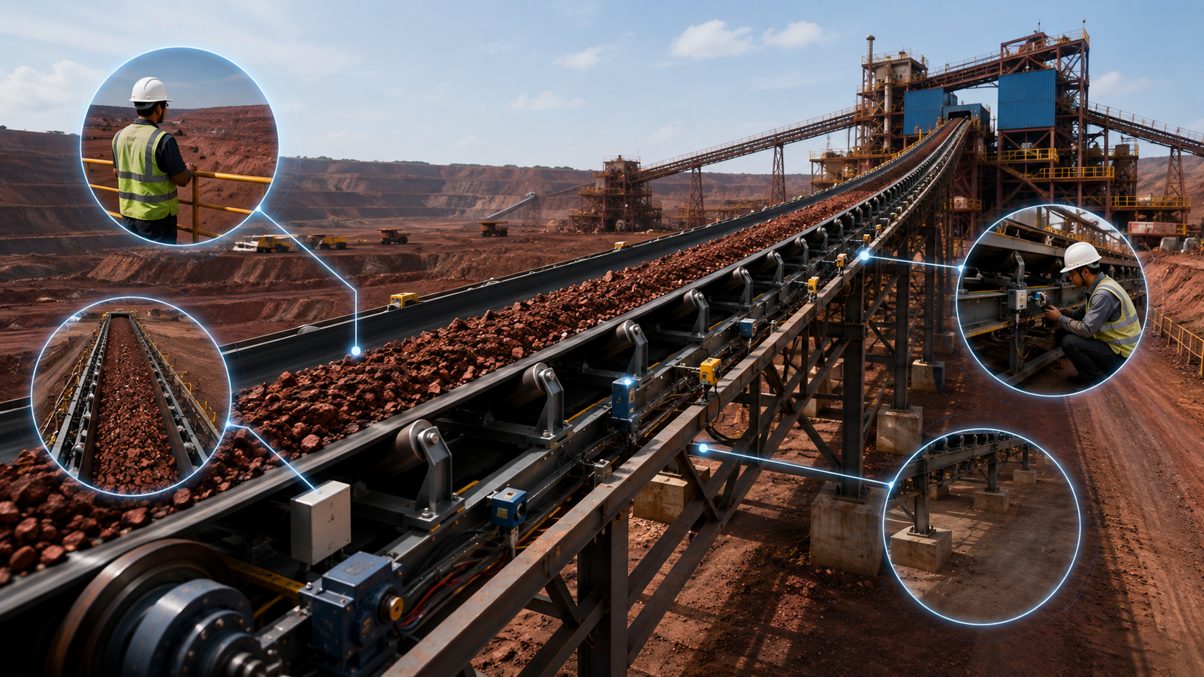
The strongest uniqueness claim is:
TELENOVA aims to create a unified, low-cost, joint-level predictive monitoring layer that combines heterogeneous sensor data, computer vision and edge AI to continuously track conveyor-belt joint health and convert detected abnormalities into maintenance-oriented decisions.
This is more defensible than claiming:
"We invented a new belt-damage detection technology."

4.14 Design Philosophy
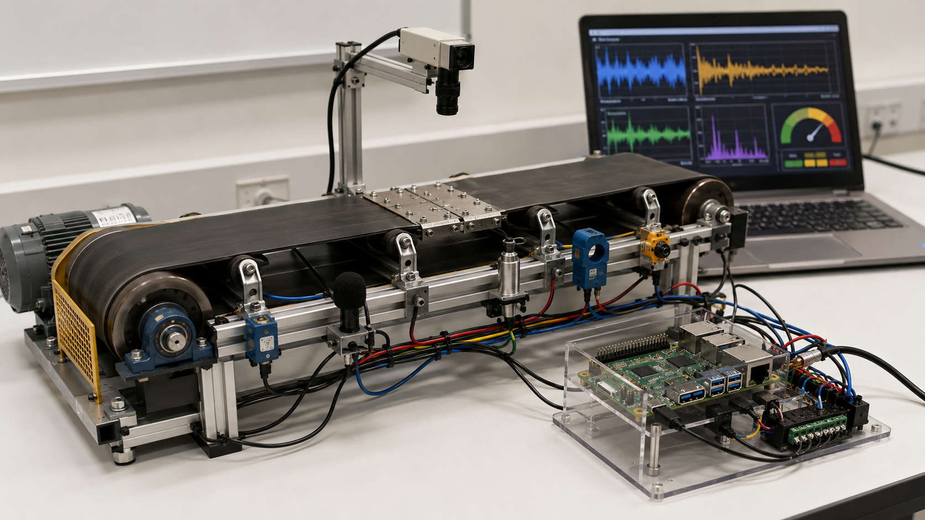
TELENOVA follows five principles:

1. Complement existing systems
It should work alongside established magnetic/NDT and protection systems where available.

2. Detect before failure
Prioritize degradation trends rather than only catastrophic failure detection.

3. Local intelligence
Perform as much processing as practical at the edge.

4. Explainable output
The dashboard should show why a joint has been flagged.
Example:
J18 — Warning
Vibration ↑
Temperature ↑
Acoustic anomaly detected
Vision: minor edge damage
rather than simply:
AI: 87% fault

5. Scalable architecture
A prototype may use a single Raspberry Pi and a few sensors, while the industrial version can evolve toward distributed sensor nodes, gateways and multiple conveyors.

4.15 MVP vs Future Scope
This distinction is very important for your SIH presentation.

MVP — What you can realistically demonstrate

Hardware
- Small conveyor prototype
- Motor
- Rubber belt
- Artificial splice/joint
- Accelerometer
- Microphone
- Temperature sensor
- Motor-current sensing
- Camera
- Raspberry Pi

Software
- Data acquisition
- DSP
- Feature extraction
- Basic ML
- Vision detection
- Joint identification
- Health score
- Dashboard
- Alerts

Demonstration
Create controlled faults such as:
Normal → abnormal vibration → joint anomaly → vision-detected damage → health score changes → dashboard warning
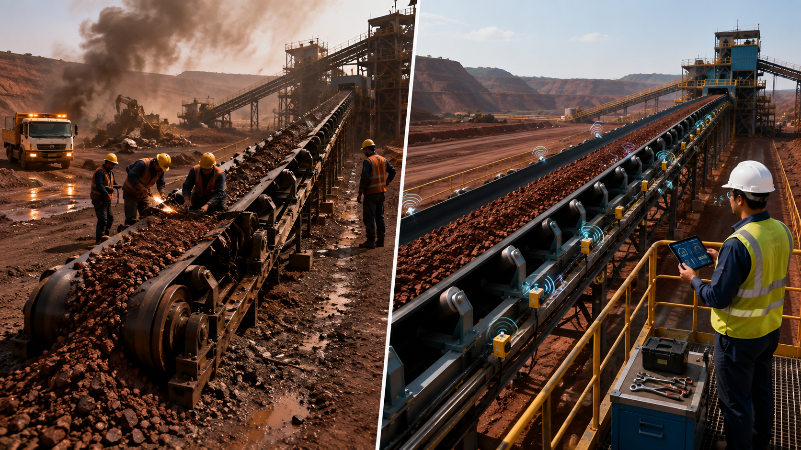

Future Industrial Version
The prototype can later evolve toward:
- Distributed ESP32 sensor nodes
- LoRa communication
- Industrial edge gateway
- Advanced magnetic/NDT integration
- Thermal cameras
- More advanced deep learning
- RUL prediction
- PLC/SCADA integration
- Automated maintenance planning
- Digital twin
- Multiple conveyor monitoring
- Drone-based inspection

4.16 Proposed TELENOVA Architecture
CONVEYOR BELT
│
┌──────────────┼──────────────┐
│ │ │
Vibration Acoustic Temperature
Sensor Sensor Sensor
│ │ │
├──────────────┼──────────────┤
│ │ │
Current Speed Camera
Sensor Sensor / Vision
│ │ │
└──────────────┼──────────────┘
↓
DATA ACQUISITION
↓
EDGE PROCESSING
↓
┌───────────┴───────────┐
↓ ↓
DSP COMPUTER VISION
↓ ↓
FEATURE EXTRACTION DEFECT FEATURES
└───────────┬───────────┘
↓
AI / ML ANALYSIS
↓
SENSOR FUSION
↓
JOINT HEALTH ENGINE
↓
┌────────────────┼────────────────┐
↓ ↓ ↓
Health Score Risk Level Degradation
Trend
└────────────────┼────────────────┘
↓
DASHBOARD
↓
MAINTENANCE DECISION

Bill of Materials
Hardware
Item | Qty | Approx. Price (₹) | Notes
Raspberry Pi 4 Model B, 4GB | 1 | 5,500–6,500 | Genuine boards vary a lot by seller (₹5,200 up to ₹11,000+ at some "official" retailers) — buy from Robu.in/Robocraze/ElectronicsComp, avoid inflated marketplace listings
MicroSD card, 32GB (Class 10/A1) | 1 | 400–600 | For Raspberry Pi OS + logging
Pi power supply (5V/3A USB-C) | 1 | 400–600 | Pi 4 needs the full 3A — don't reuse a phone charger
ESP32-WROOM-32 DevKit (38-pin) | 1–2 | 280–400 each | ₹280-400 confirmed range across multiple Indian sellers
Sensors
Item | Qty | Approx. Price (₹) | Notes
MPU6050 accelerometer/gyro (GY-521 breakout) | 1–2 | 120–200 each | I2C, well-documented
MLX90640 thermal array (32×24, I2C) | 1 | 2,500–4,000 | Price varies significantly by FOV variant (55°/110°) and seller (Robu/Robocraze/7Semi)
IR break-beam sensor OR Hall-effect sensor + magnet | 1 set | 80–150 | Joint-pass trigger
Pi Camera Module (v2/v3) or USB webcam | 1 | 800–2,500 | Pi Camera v2 (~₹800-1,200) is fine for demo; USB webcam also works if budget-tight
ACS712 current sensor (optional, Node 2) | 1 | 100–150 | Only if you add motor-load monitoring
DS18B20 temp sensor (optional, backup/simple temp) | 1–2 | 80–120 | Cheap fallback if MLX90640 setup has issues
Actuation
Item | Qty | Approx. Price (₹) | Notes
L298N or BTS7960 motor driver | 1 | 150–400 | BTS7960 for higher current if your demo motor draws more
DC gear motor (12V, with pulley mount) | 1 | 300–800 | Drives your small belt loop
Relay module (5V, 1/2-channel) | 1 | 80–150 | Backup/simple on-off control alongside PWM
12V power supply/battery pack for motor | 1 | 300–600 | Keep motor power separate from Pi/ESP32 logic power
Mechanical
Item | Approx. Price (₹) | Notes
Small conveyor belt (rubber/fabric strip, ~1-2m loop) | 300–800 | Or repurpose a scrap belt/treadmill belt section
Idler rollers + frame (wood/aluminium extrusion) | 500–1,500 | DIY-buildable; aluminium extrusion is more presentable for judges
Swappable "faulty joint" sample (stitched patch/misaligned splice) | ~0 (DIY) | Make 2-3 interchangeable joint samples to demo live
Misc/wiring
Item | Approx. Price (₹)
Breadboards, jumper wires, I2C cables | 300–500
Buzzer + LEDs (status indicators) | 50–100
Enclosure/mounting hardware | 300–600

Total estimate: ₹13,000 – ₹20,000

The central idea
TELENOVA is not just a collection of sensors.
It is the complete chain:
Physical conveyor → multimodal sensing → signal intelligence → joint identification → AI-based assessment → health tracking → maintenance decision.
That should become the central theme of your proposed solution.

RESEARCH AND REFERENCES
